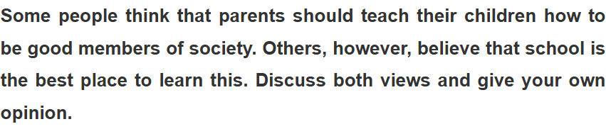

There are people who argue that it is the parents’ responsibility to educate their children how to adjust to society, whereas some people believe the school can do a better job. Both views will be discussed, but I believe it is up to individuals to learn the social skills.

To begin with, it is true that children can learn from their parents, given the fact that they have experienced society for at least more than 20 years, which is enough to form their own logic. Although their logic could not fully explain in some situations, it is still enough to teach the very basic social norms to their children. However, this view is not shared by everyone, therefore some people take a different view. A school can be a better place to learn social norms, since the children have to encounter others constantly. By having a discussion or even making a few mistakes, they can naturally learn what to do and what not to do by themselves.

In my opinion, I believe both arguments are valid, but fundamentally, it is up to individuals to learn from their parents or experience because the choices are ultimately on their side. Even though the parents have strengthened their common senses which are extremely delicate and easy to understand, it is no use if the children refuse to listen to their parents. A similar scenario could happen in school, even if they made a mistake to other students.

In conclusion, I believe children can indeed learn how to socialize with others from their parents or in school, but more fundamentally, it is always up to them to take the advice or not.

